Design Principles and Patterns

Week 1 :
Mandatory Exercises :
Exercise 1:
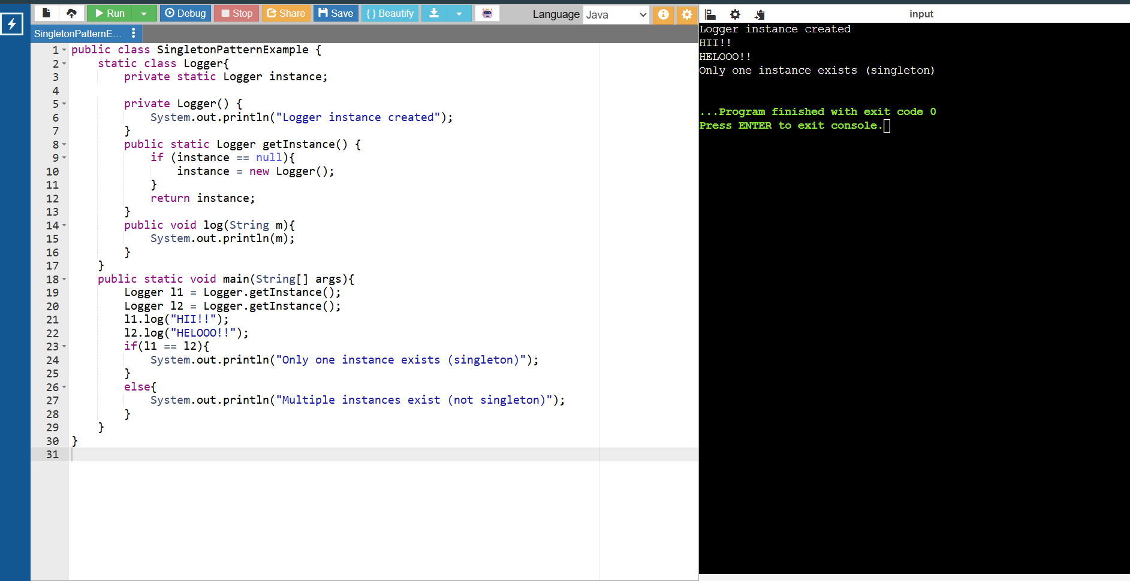

Exercise 2 :
